CUSTOM LOSS FUNCTION

Prepared By :

Yogesh Kumar(23124052)

Swayam Bhushan Singh(23124047)

Abstract:

Loss functions are fundamental to training machine learning models, as they quantify the discrepancy between predicted and actual outcomes, steering the optimization process. While traditional loss functions like Mean Squared Error (MSE) and Cross-Entropy are widely employed, they often fall short in capturing the unique requirements of certain tasks, particularly in time-series forecasting. These standard methods may struggle to enforce desirable properties such as prediction smoothness, which is critical in applications like weather forecasting or stock price prediction.
To address these limitations, we propose Custom_Loss, a custom loss function tailored for time-series data. Custom_Losscombines the predictive accuracy of MSE with an additional smoothness penalty term that discourages abrupt changes between consecutive predictions. By incorporating this smoothness constraint, the loss function ensures that predictions not only minimize the error relative to the true values but also maintain a stable and realistic flow across time steps. This dual-objective approach balances accuracy and consistency, enabling models to produce predictions that are both precise and coherent, making Custom_Lossparticularly suited for dynamic and sequential data forecasting tasks.

CONTENTS

- Introduction

- Methodology
  - Combination Loss Functions
  - MSE(Mean Squared Error )
  - Smothness Penalty

- Experiments
  - Jena City Climate Dataset
    - Plotting the Loss of Model 1
    - Metrics on Model 1
    - Plotting the loss of Model 2
    - Metrics on Model 2
  - S&P(^GSPC) Stock Price Dataset
    - Plotting the loss
    - Test Data Plots
    - Metrics on Test Data
  - Google Finance Dataset
    - Plotting the Loss
    - Test Data Plots
    - Metrics on Test Data

- Result

- Introduction :

Custom_Loss builds on the foundational Mean Squared Error (MSE) loss widely used in machine learning models, enhancing it with a specialized penalty term tailored for time-series forecasting. This loss function combines the predictive accuracy of MSE with a smoothness penalty that encourages consistency and harmony in the predicted time-series flow. The penalty is applied when consecutive predictions exhibit abrupt changes, with the magnitude of the penalty increasing based on the severity of these changes.
By integrating this smoothness constraint alongside the traditional MSE component, Custom_Loss enables models to achieve not only lower overall prediction error but also smoother and more coherent predictions over time. This dual-objective design is particularly valuable in time-series tasks, such as weather forecasting and stock price prediction, where maintaining the continuity of trends is as crucial as ensuring accurate values.

- Methodology :

  - Combination of loss functions :

The custom loss function you've implemented for Custom_Losscombines two components:
- Mean Squared Error (MSE) loss between the true and predicted values, ensuring the model minimizes the overall prediction error.
- Smoothness Penalty, which discourages abrupt changes between consecutive predictions, encouraging a stable and continuous flow in the predicted time series. This penalty helps maintain consistency over time by penalizing large fluctuations in predictions, ensuring smoother transitions between time steps.

  - MeanSquaredError(MSE):
The MSE loss is computed between the true values

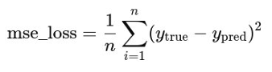

  - Smoothness Penalty :
The Smoothness Penalty measures the absolute difference between each consecutive pair of predictions in the time series. It sums the absolute differences between the predicted value at time step i and the predicted value at the next time step i+1, then averages them over all consecutive pairs.
The penalty ensures that if there are sudden jumps or sharp changes between consecutive predictions, the model is penalized. This encourages the model to generate predictions that change gradually over time, maintaining smooth transitions in the time series, rather than producing erratic or volatile predictions.

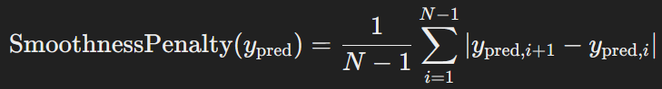

Custom_Loss = lambda_1(MSE) +lambda_2(Smoothness Penalty)

Where λ1​ and λ2​ are hyperparameters that control the relative importance of the MSE and smoothness penalty terms.

- Experiments :

  - Jena city climate dataset : The dataset being used for this experiment is the Jena Climate Dataset, which contains multiple time-based meteorological values recorded since 2009. For this analysis, we focus exclusively on the temperature (T (degC)) readings to perform time-series forecasting.

The data is preprocessed, scaled, and passed to multiple models to evaluate the performance of the custom loss function compared to conventional ones. Each model is trained for 50 epochs with identical training parameters, and the graph of the loss function is plotted to analyze the results.

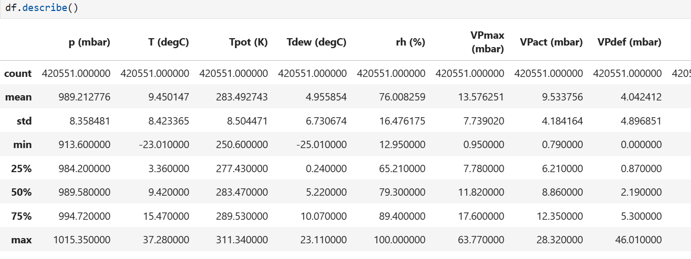

    - Plotting the Graphs of model 1:
The following plots illustrate how the model 1 fit the data using different loss functions, providing a comparative analysis of their performance.

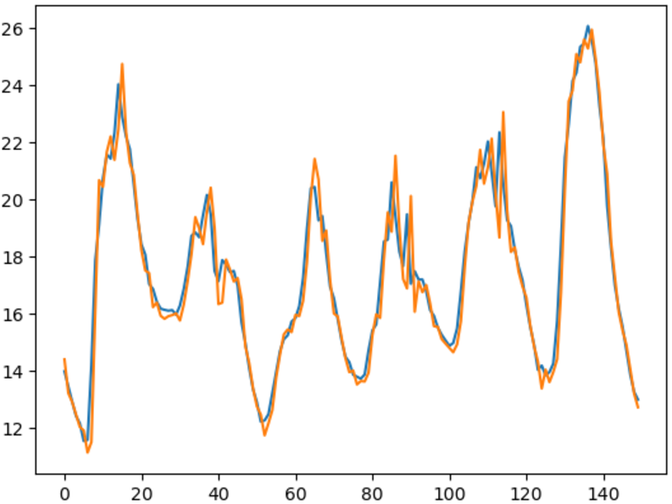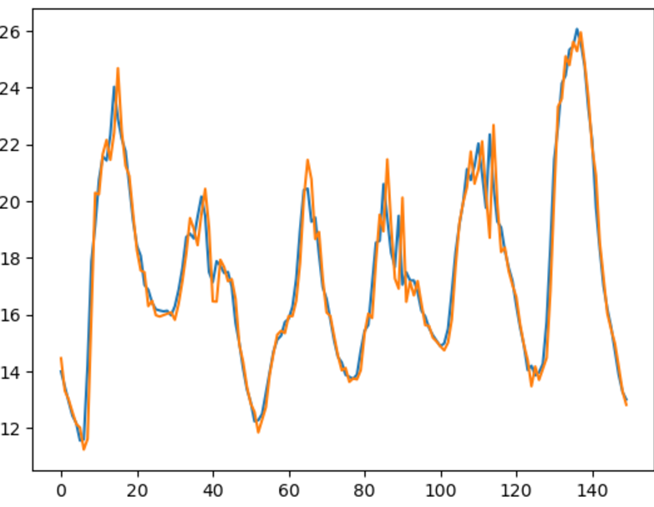
Mean Absolute Loss Mean Squared Loss

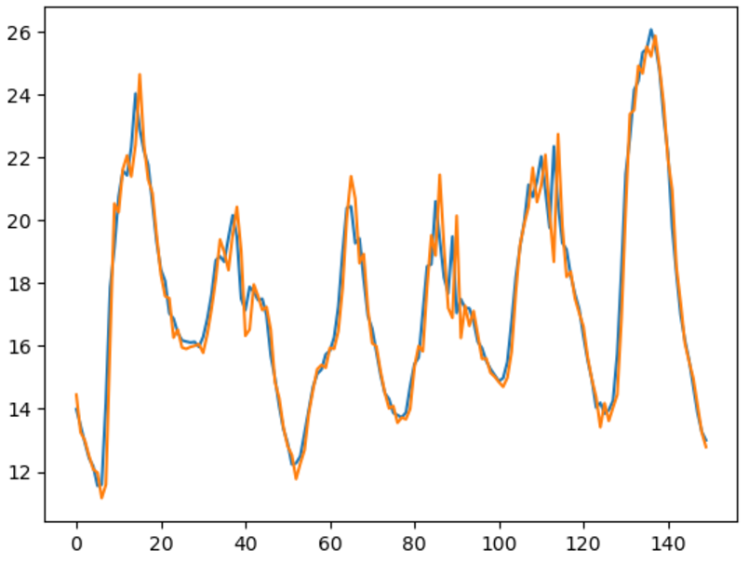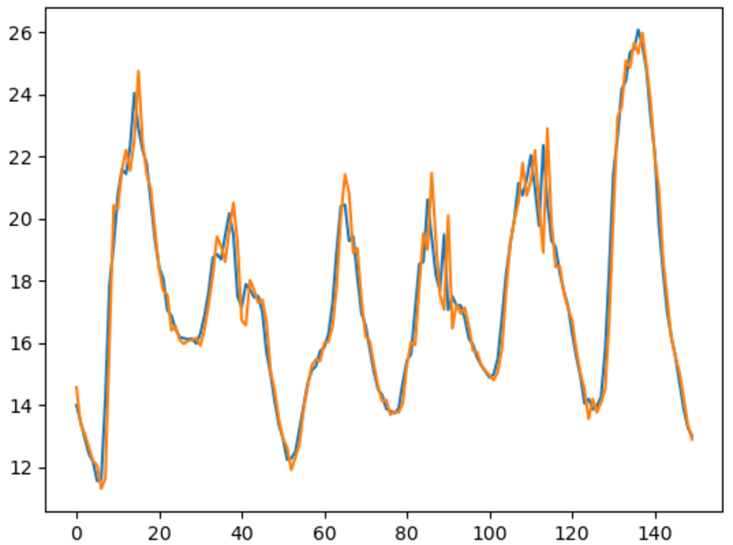

Huber Loss Custom Loss(Custom_Loss)
*True values are plotted by BLUE and ORANGE plots predicted values
* We are only plotting some parts of test data not the whole test data

    - Metrics on Test Data of Model 1:

Loss Used | MSE | MAE | RMSE | R2 score
Mean squared loss | 0.58654572 | 0.52120954 | 0.76586273 | 0.99157506
Mean absolute loss | 0.60265289 | 0.52511751 | 0.77630721 | 0.99134371
Huber loss | 0.59114347 | 0.52295504 | 0.76885855 | 0.99157506
Custom_Loss | 0.58482493 | 0.52196408 | 0.76473847 | 0.99159978

    - Plotting the Graphs of Model 2:
The following plots illustrate how model 2 fit
the data using different loss functions, providing
a comparative analysis of their performance.

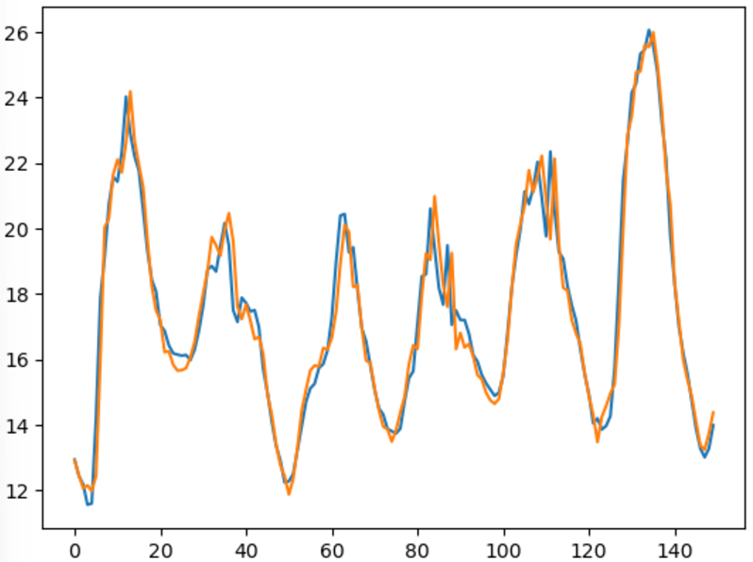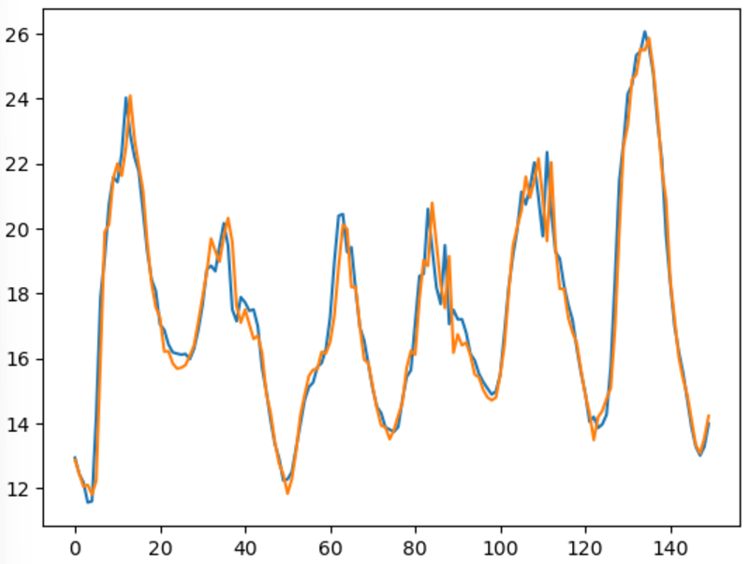
Mean Squared Loss Mean Absolute Loss

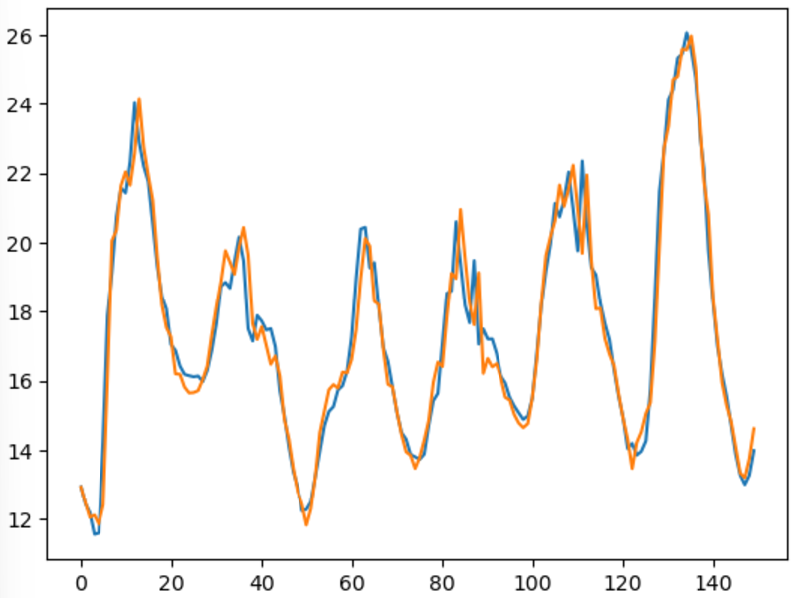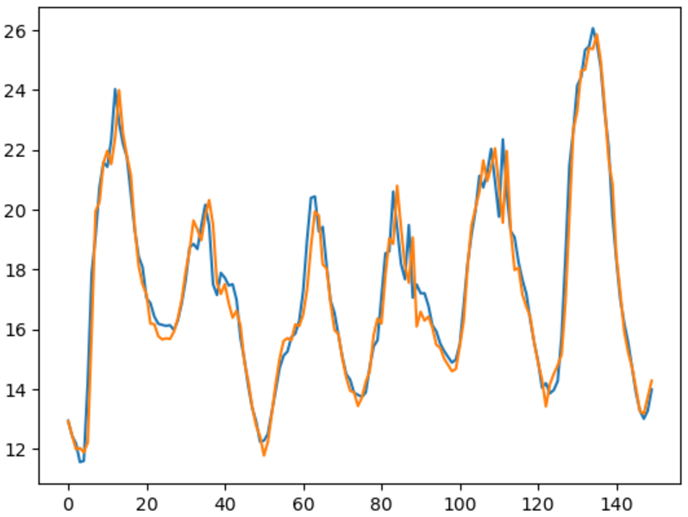
Huber Loss Custom Loss(Custom_Loss)

    - Metrics on Test Data of Model 2:

Loss Used | MSE | MAE | RMSE | R2 score
Mean squared loss | 0.44679710 | 0.46134354 | 0.66842883 | 0.993584
Mean absolute loss | 0.45060931 | 0.45575873 | 0.67127439 | 0.993527
Huber loss | 0.44089567 | 0.45818937 | 0.66399975 | 0.993667
Custom_Loss | 0.43972482 | 0.45856769 | 0.66311750 | 0.993686

Our team has achieved improved efficiency with our custom loss function. The custom loss function demonstrates a higher R2 score compared to the other three loss functions.

  - S&P(^GSPC) Stock Price Dataset : The dataset used for the first test case is the ^GSPC dataset, which contains historical financial data from 1930 to 2024-01-01. For this analysis, we focus exclusively on the Adjusted Close (Adj Close) value for time-series forecasting.
The data is scaled and passed to multiple models to evaluate the performance of the custom loss function in comparison to conventional ones. Each model is trained for 50 epochs with identical training parameters, and the loss function's behavior is analyzed through plotted graphs.

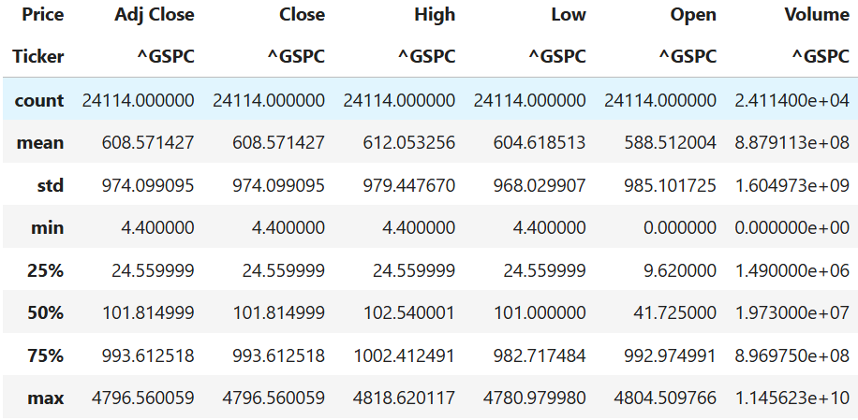

    - Plotting the Loss :

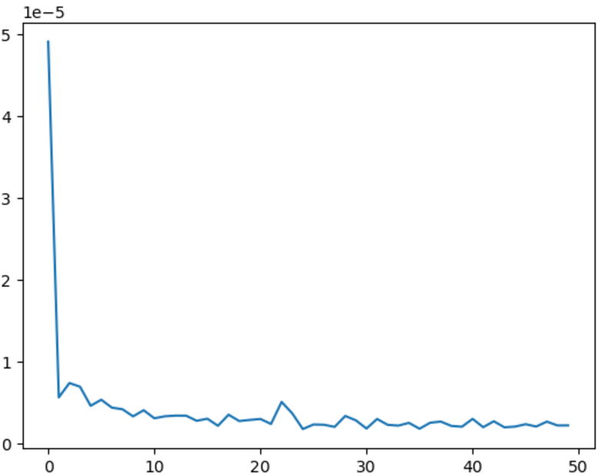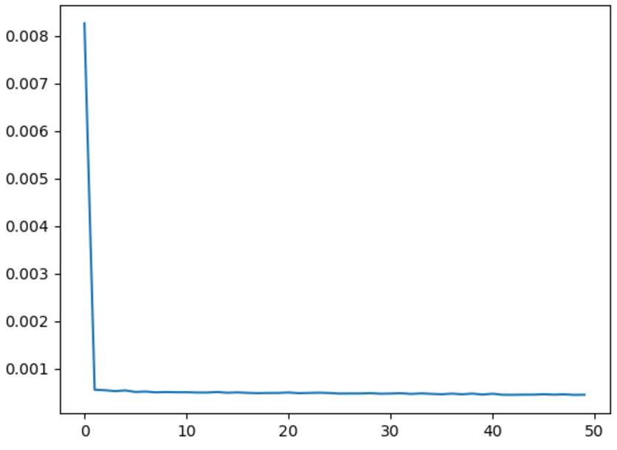
Mean Squared loss Mean Absolute Loss

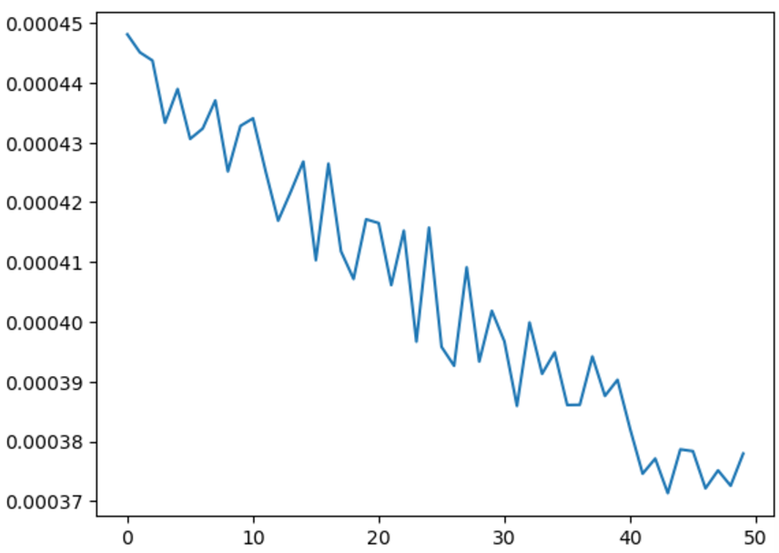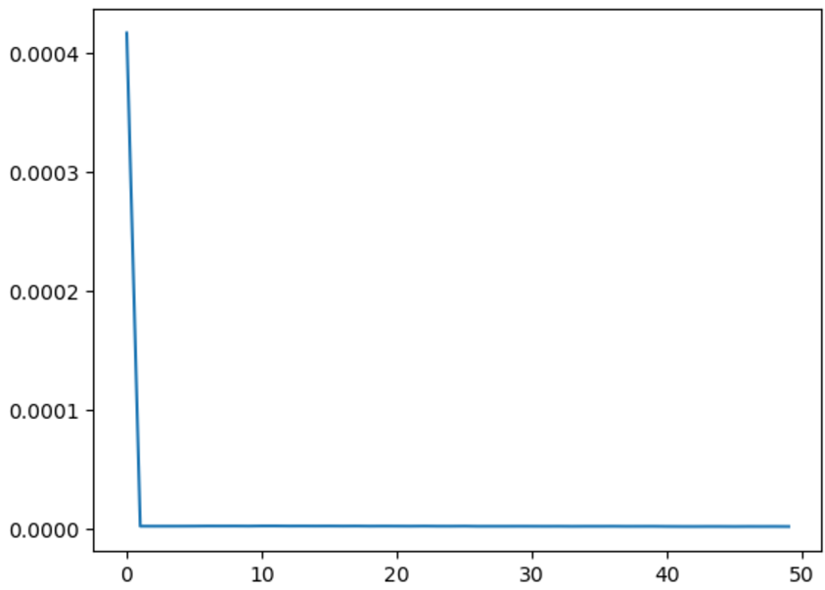
Huber Loss Custom Loss(Custom_Loss)

    - Test Data Plots :

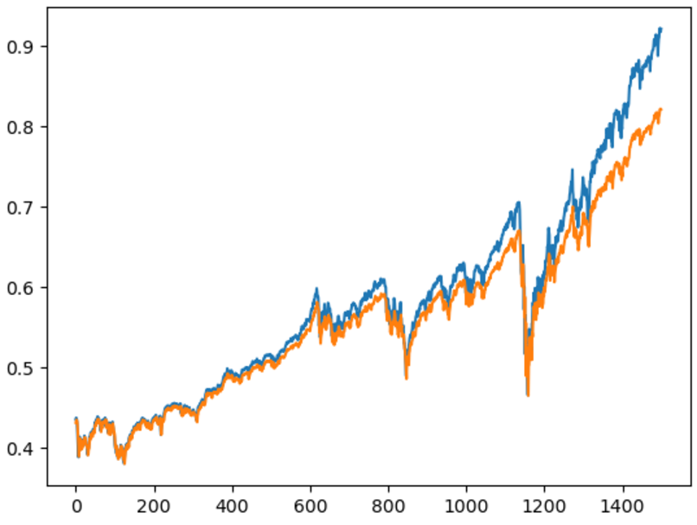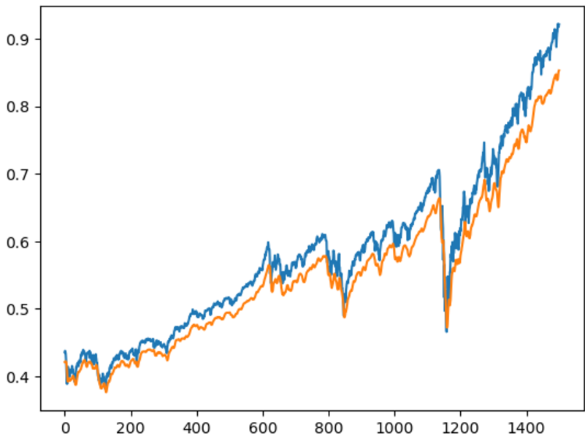

Mean Square Loss Mean Absolute Loss

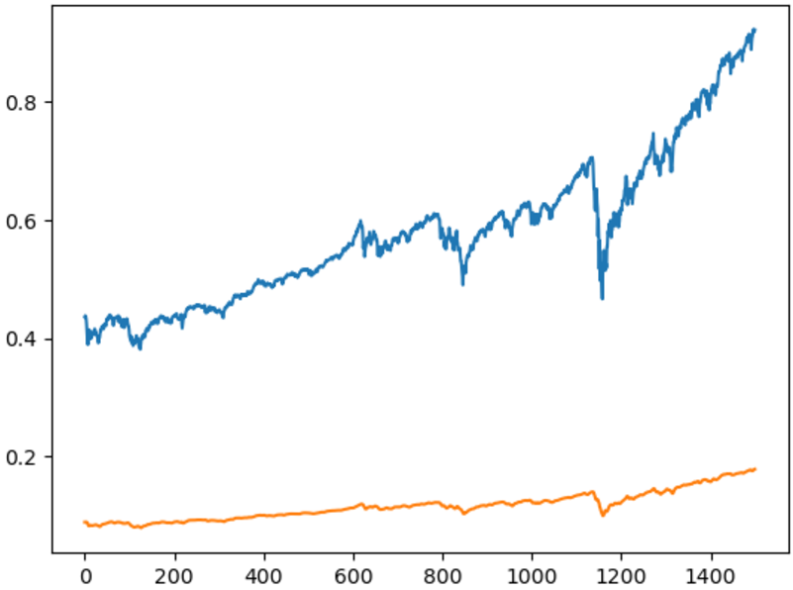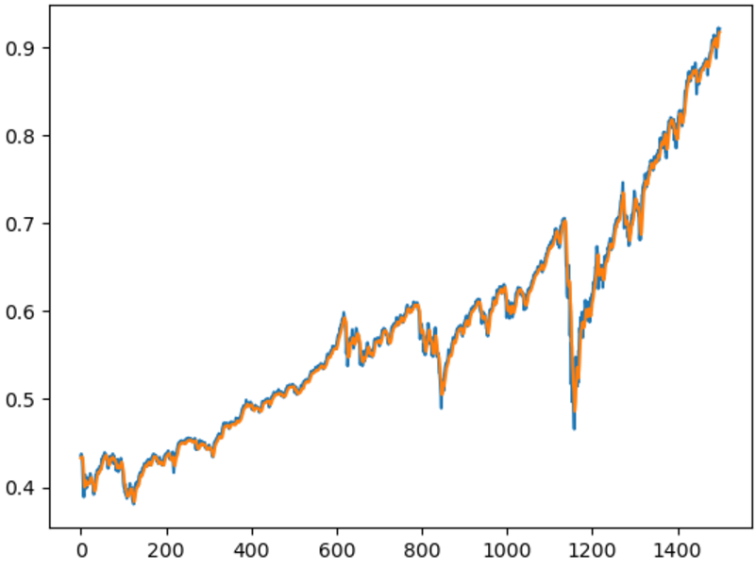
Huber Loss Custom_Loss

    - Metrics on Test Data :

Loss Used | MSE | MAE | RMSE | R2 score
Mean squared loss | 0.00297031 | 0.03953032 | 0.05450055 | 0.90646292
Mean absolute loss | 0.00191602 | 0.03825838 | 0.04377237 | 0.93966321
Huber loss | 0.30732715 | 0.53497402 | 0.55437095 | Very Low
Custom_Loss | 0.00010224 | 0.00723330 | 0.01011186 | 0.99678008

Our team has achieved improved efficiency with our custom loss function. The custom loss function demonstrates a higher R2 score compared to the other three loss functions.

  - Google Finance Dataset : The dataset used for the first test case is the Google finance dataset, which contains historical financial data from 1995 to 2024-01-01. For this analysis, we focus exclusively on the Adjusted Close (Adj Close) value for time-series forecasting.
The data is scaled and passed to multiple models to evaluate the performance of the custom loss function in comparison to conventional ones. Each model is trained for 50 epochs with identical training parameters, and the loss function's behavior is analyzed through plotted graphs.

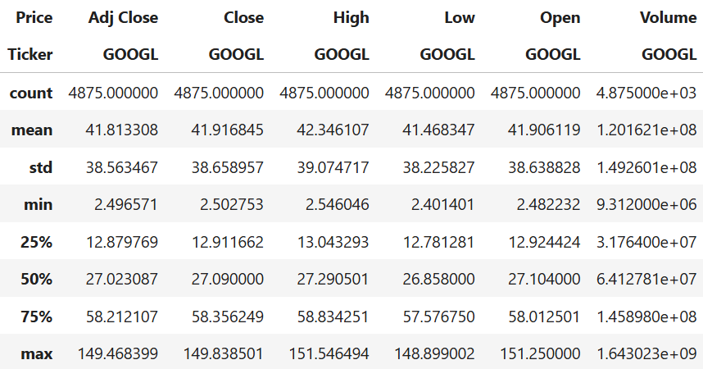

    - Loss Plots :

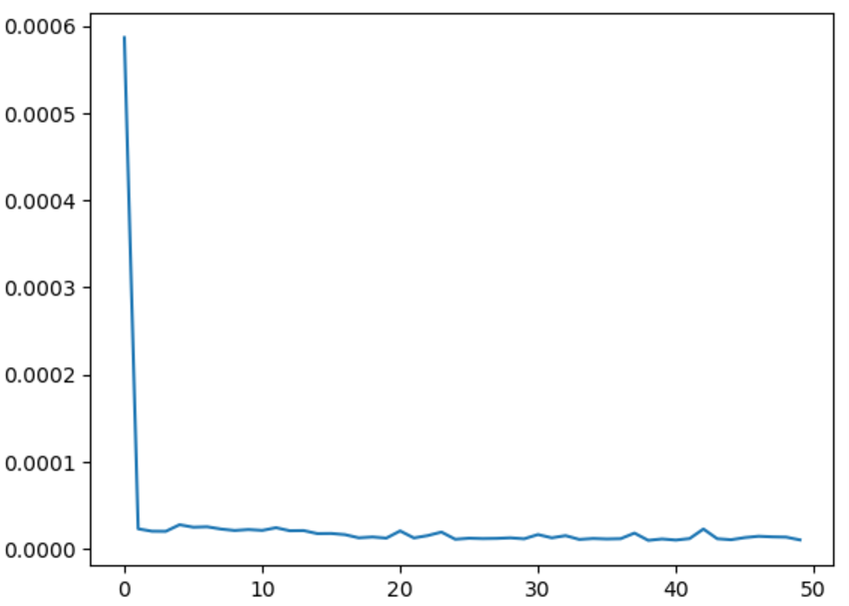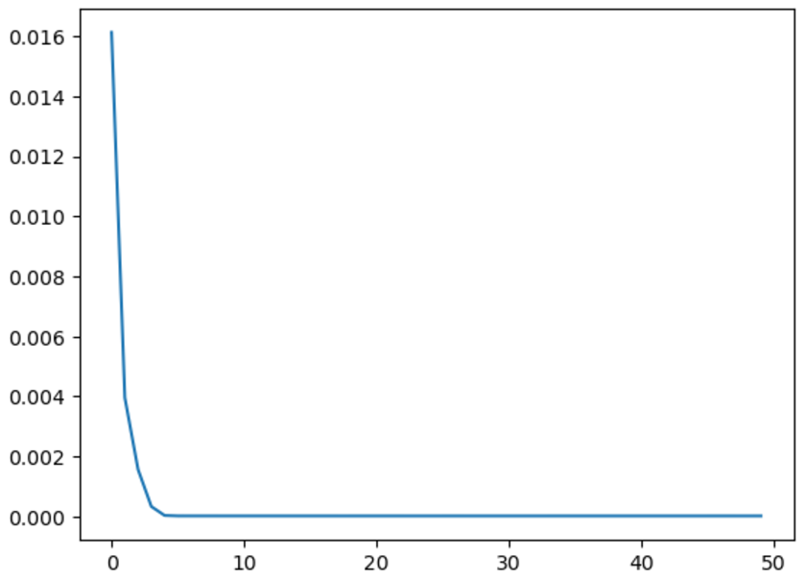
Mean Squared Loss Custom_Loss

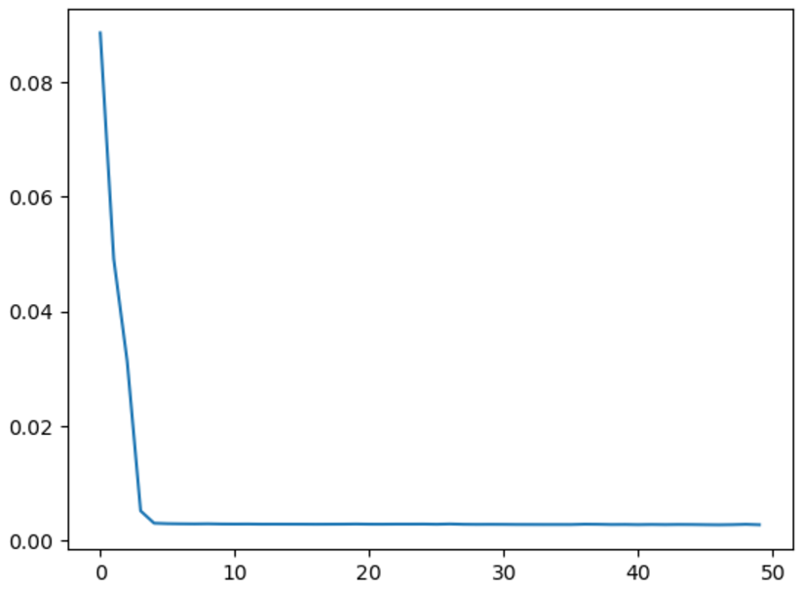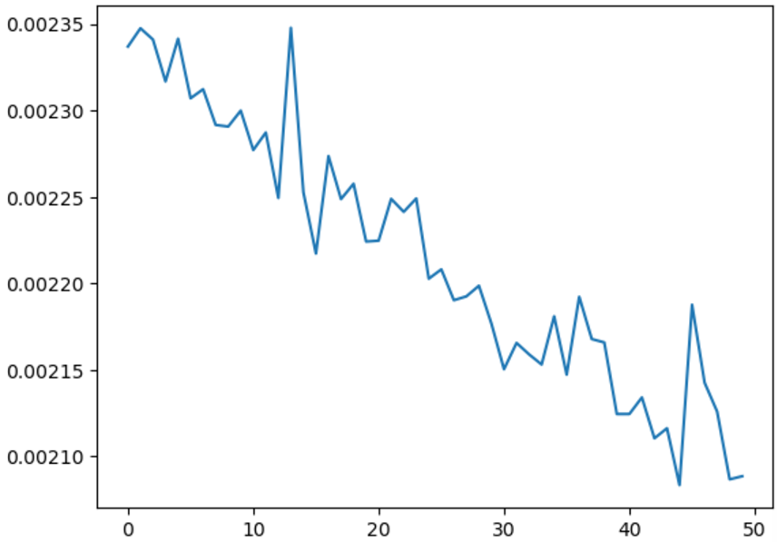
Mean Absolute Loss Huber Loss

    - Test Data Plots :

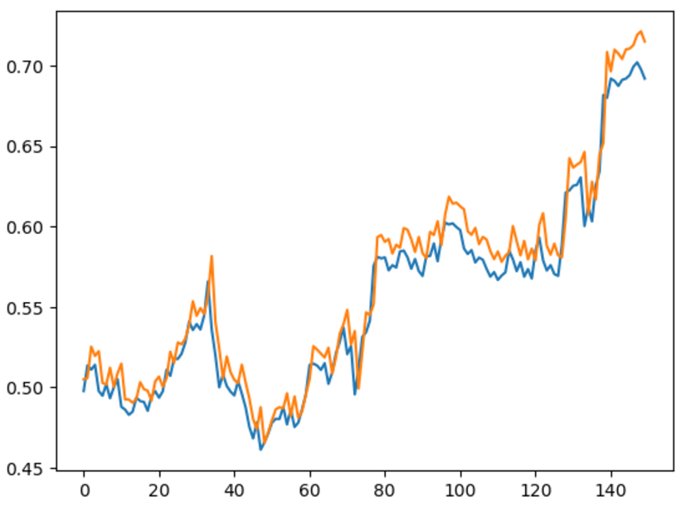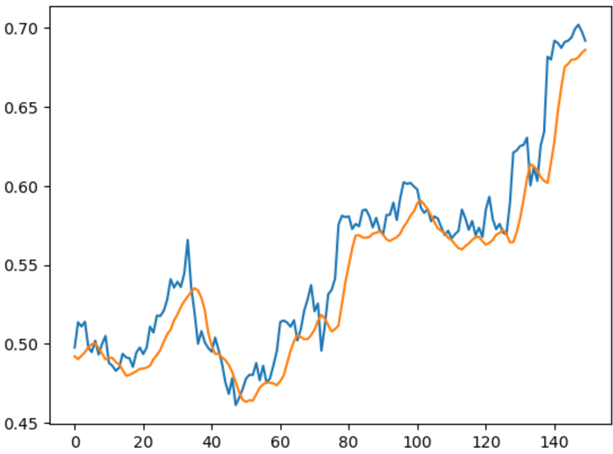
Mean Square Loss Custom _Loss

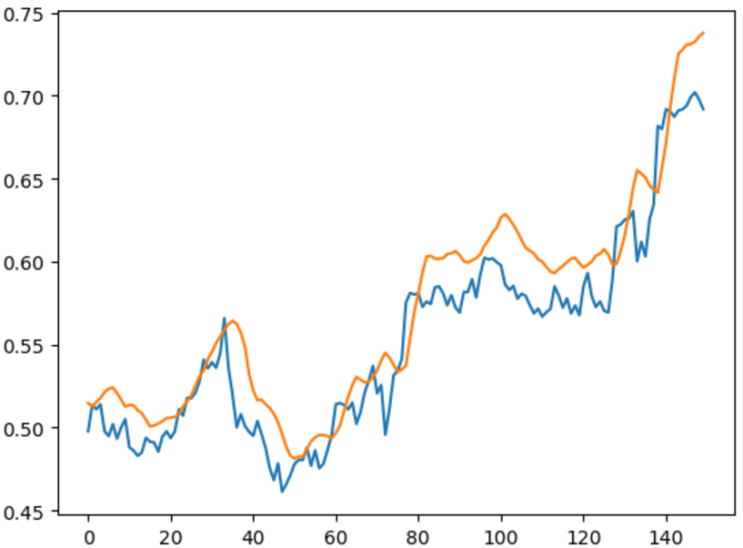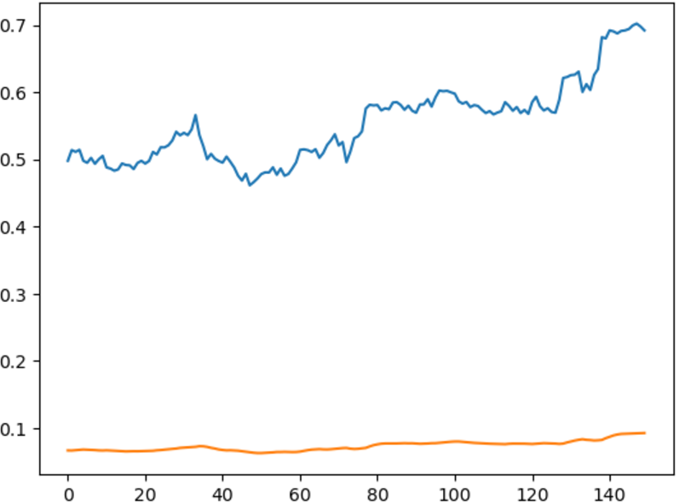
Mean Absolute Loss Huber Loss

Loss Used | MSE | MAE | RMSE | R2 score
Mean squared loss | 0.00072456 | 0.02223557 | 0.02691782 | 0.96835264
Mean absolute loss | 0.00352042 | 0.05064927 | 0.05933314 | 0.84623686
Huber loss | 0.43478882 | 0.64602214 | 0.65938519 | Very low
Custom_Loss | 0.00059425 | 0.01923587 | 0.02437743 | 0.97404424

Our team has achieved improved efficiency with our custom loss function. The custom loss function demonstrates a higher R2R2 score compared to the other three loss functions.

Result :
In conclusion, the custom loss function developed in this project effectively balances prediction accuracy and the smoothness of the output time series. By combining the Mean Squared Error (MSE) with a smoothness penalty, it ensures that the model minimizes both the error relative to the true values and the abrupt changes between consecutive predictions.
This approach is particularly valuable for time-series forecasting tasks where maintaining a coherent and realistic flow of predictions—such as in temperature forecasting or other sequential data modeling—is crucial. The inclusion of the smoothness penalty allows the model to learn patterns that are not only accurate but also consistent over time, reflecting the natural dynamics of the data.
The dual-objective nature of the loss function facilitates a more refined training process, offering improved performance in scenarios where both precision and temporal consistency are essential. Further testing and refinement can enhance its robustness and adaptability to other domains, making it a powerful tool for tackling complex time-series modeling challenges.

